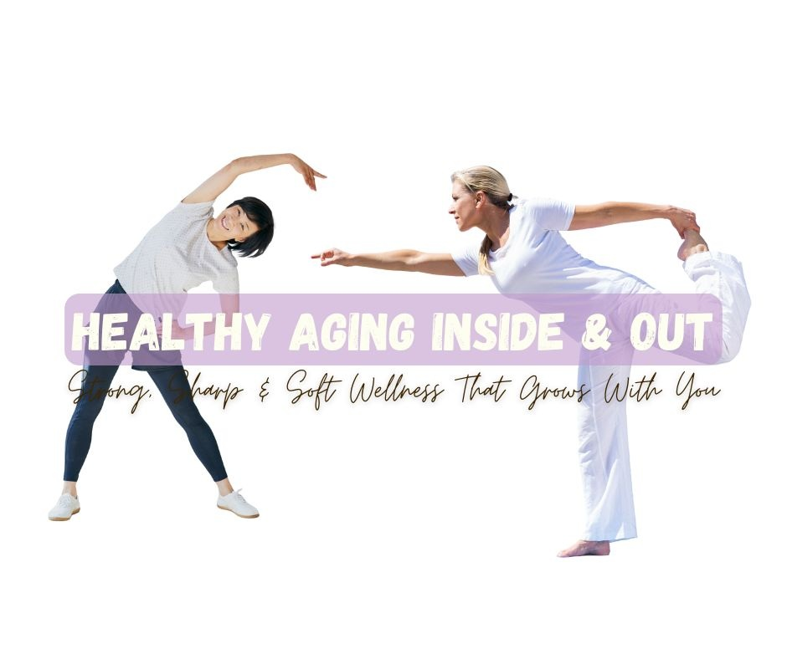

Workbook Healthy Aging Inside & Out workbook

This Healthy Aging Inside & Out Guided Journal was created to help you explore, apply, and personalize the twelve foundational habits of strong, sharp, and soft living. It’s not just a workbook, it’s a reflective space to slow down, listen to your body, and celebrate your evolution.

Each section includes:
- An Affirmation: a gentle focus statement to center your mindset.
- Five Journal Prompts: open-ended reflections to deepen self-awareness and create meaningful action.
- A Reflection Cue: a short phrase that captures the essence of the habit and invites pause.
You’ll also find extra space for notes, insights, and ideas as you go.

How to Work Through Your Journal
- Choose Your Own Pace
There’s no right way to move through these pages. You can explore one habit per week or pick the one that feels most relevant to your life right now.

- Create a Ritual Around It
Set aside 10–20 minutes of quiet time, such as during your morning tea, after a walk, or before bed. Light a candle, breathe deeply, and allow yourself to arrive on the page.

- Write Freely, Without Judgment
This isn’t about perfect handwriting or polished answers. It’s about honesty, curiosity, and connection with yourself. Let your responses flow, even if single words or fragments count.

- Reflect and Revisit
Your answers may change over time. Revisit habits every few months to see how your body, mind, and heart are evolving. Growth is rarely linear; it’s a circle, not a race.

- Celebrate Small Shifts
Progress isn’t measured in miles but in moments: the deeper breath, the restful night, the kind word to yourself. Acknowledge what’s working.

Tips for Getting the Most Out of It
- Keep your workbook somewhere visible on your nightstand, next to your yoga mat, or wherever you naturally pause.
- Add dates to your entries to track your evolution over time.
- Pair it with a habit tracker to stay mindful of your daily actions.
- Remember: You’re not fighting aging, you’re cultivating vitality.
Let’s Get Started!!!

Habit 1: Start with Strength
Affirmation: My strength is my freedom. Every small effort counts.

Strength, to me, means…

I feel strongest when…

The activities I’d love to do with more ease are…

One small strength habit I can begin this week is…

I’ll know I’m growing stronger when I notice…

Reflection cue: Strong doesn’t mean hard it means capable, steady, and alive.

Habit 2: Gentle Cardio for Lifelong Energy
Affirmation: My heart leads the rhythm of my energy.

The movement that brings me joy is…

After I walk, dance, or move lightly, my body feels…

The time of day I feel most energized to move is…

I could make movement more joyful by…

I plan to celebrate my progress by…

Reflection cue: Joyful motion is sustainable motion.

Habit 3: Daily Mobility & Flexibility
Affirmation: My body loves to move even in small ways.

The part of my body that most needs freedom right now is…

When I stretch or move gently, I notice…

To remind myself to take “movement breaks,” I will…

Freedom in my body feels like…

The small practice that helps me stay flexible is…

Reflection cue: Freedom lives in motion, not perfection.

Habit 4: Cognitive Clarity Staying Sharp on Purpose
Affirmation: My mind stays curious, creative, and clear.

My mind feels clearest when…

I come alive mentally when I’m learning or exploring…

One new skill, game, or habit that sparks my curiosity is…

I can support my focus by…

I’ll make time for mental renewal by…

Reflection cue: Learning something new keeps the lights on inside.

Habit 5: Sleep as a Strategy, Not a Struggle
Affirmation: Rest is my reset, my body knows how to restore itself.

Lately, my sleep has felt…

The biggest thing that interferes with my rest is…

My ideal bedtime routine would include…

I want my sleep space to feel…

Each night, I’ll signal “time to rest” by…

Reflection cue: Rest is not earned it’s honored.

Habit 6: Eating to Support the Aging Body
Affirmation: I nourish my body with love, not rules.

My relationship with food has evolved in these ways…

Foods that truly nourish me are…

I feel my best when I eat…

I plan to bring more color, protein, or fiber to my meals by…

Eating as an act of self-care looks like…

Reflection cue: Every meal is a chance to practice self-respect.

Habit 7: Supplementing Wisely
Affirmation: I choose what truly supports my body.

The supplements or vitamins I currently take are…

I take them because…

I’d like to understand more about…

My body feels best when I…

To make my routine more intentional, I will…

Reflection cue: Wisdom is knowing why, not just what.

Habit 8: Hormone Harmony
Affirmation: I honor the rhythms within me change is not loss.

Lately, I’ve noticed changes in my mood, energy, or sleep such as…

These changes make me feel…

What helps me feel balanced is…

I’ll discuss my hormone health with my provider when…

When I feel steady inside, it’s usually because…

Reflection cue: Balance isn’t static; it’s the dance of adjustment.

Habit 9: Stress Management for Cellular Health
Affirmation: Calm is my superpower.

The things that most often trigger my stress are…

When I’m stressed, my body feels…

I calm myself best when I…

I could create more breathing space in my day by…

To protect my calm, I’ll remind myself to…

Reflection cue: Peace begins at the cellular level.

Habit 10: Rest & Recovery
Affirmation: I restore myself so I can rise again.

True rest feels like…

I tend to push past my limits when…

The kind of rest I need most right now is…

I’ll give myself permission to rest by…

Resting regularly helps me…

Reflection cue: Growth happens in the pause, not the push.

Habit 11: Emotional Wellness & Inner Strength
Affirmation: My emotions are teachers, not enemies.

A life change I’m navigating now is…

This change makes me feel…

I’m learning that emotional strength looks like…

I find peace and connection when I…

Today, I’m grateful for…

Reflection cue: Feeling deeply is a form of strength.

Habit 12: Building a Pro-Aging Environment
Affirmation: I’m shaping a life that supports who I’m becoming.

My space feels most supportive when…

The things that drain my energy are…

I could make my surroundings more peaceful by…

The people who lift me up are…

I’ll nurture my growth by…

Reflection cue: My environment mirrors my inner wellness.

Final Reflection
Affirmation: I am evolving with intention and grace.

The habit that feels most natural for me right now is…

The area I want to focus on next is…

I’ll celebrate progress by…

To me, being strong, sharp, and soft means…

I’ll honor this season of life by…

Reflection cue: I am not getting older; I’m growing more whole.

